**Basic Commands of SQL**

* show databases;

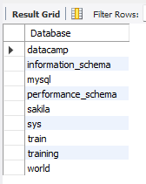

* **The USE Statement**

use training



* show tables;

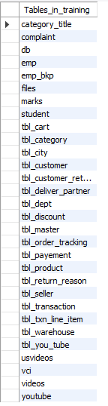

* **The Select Statement**

select * from tbl_city;

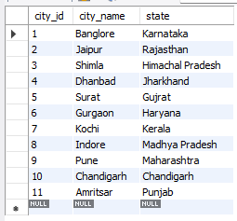

* **Selecting Specificing Column**

select state from tbl_city;

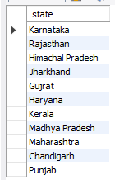

* **Select Distinct**

select distinct Student_id from marks;

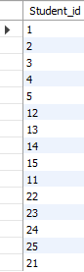

* **The Where Clause**

select city_id , state from tbl_city where city_name = 'Jaipur';

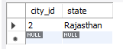

* **Combining of Where && AND**

select city_id, state from tbl_city where city_name = 'Jaipur' and state = 'Punjab';



* **Combining of Where && OR**

select city_id, state from tbl_city where city_name = 'Jaipur' or state = 'Punjab';

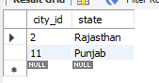

* **Combining where && IN**

select * from student where Student_name in(

select distinct student_name from student);

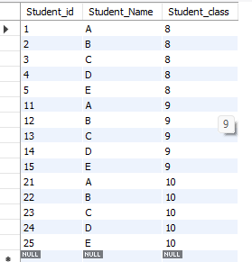

* **Like WildCard**

Select * from student where Student_Name like '%A';

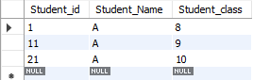

* **The Group By clause**

select * from marks group by student_id;

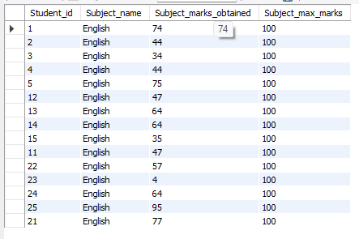

* **MUltiple Dimenion group by**

select * , max(Salary) from emp, marks,tbl_city where Gender = 'Male' group by state,dept;

